IITB-RISC

The Pipelined Implementation

Design Report

Submitted by

Sudhanshu  Nimbalkar  17D070022 | Karan Chate  17D070023 | Ark Modi  17D070022 | Prachi Goel  17D070063

DATA PATH ORGANISATION AND FUNCTIONING:

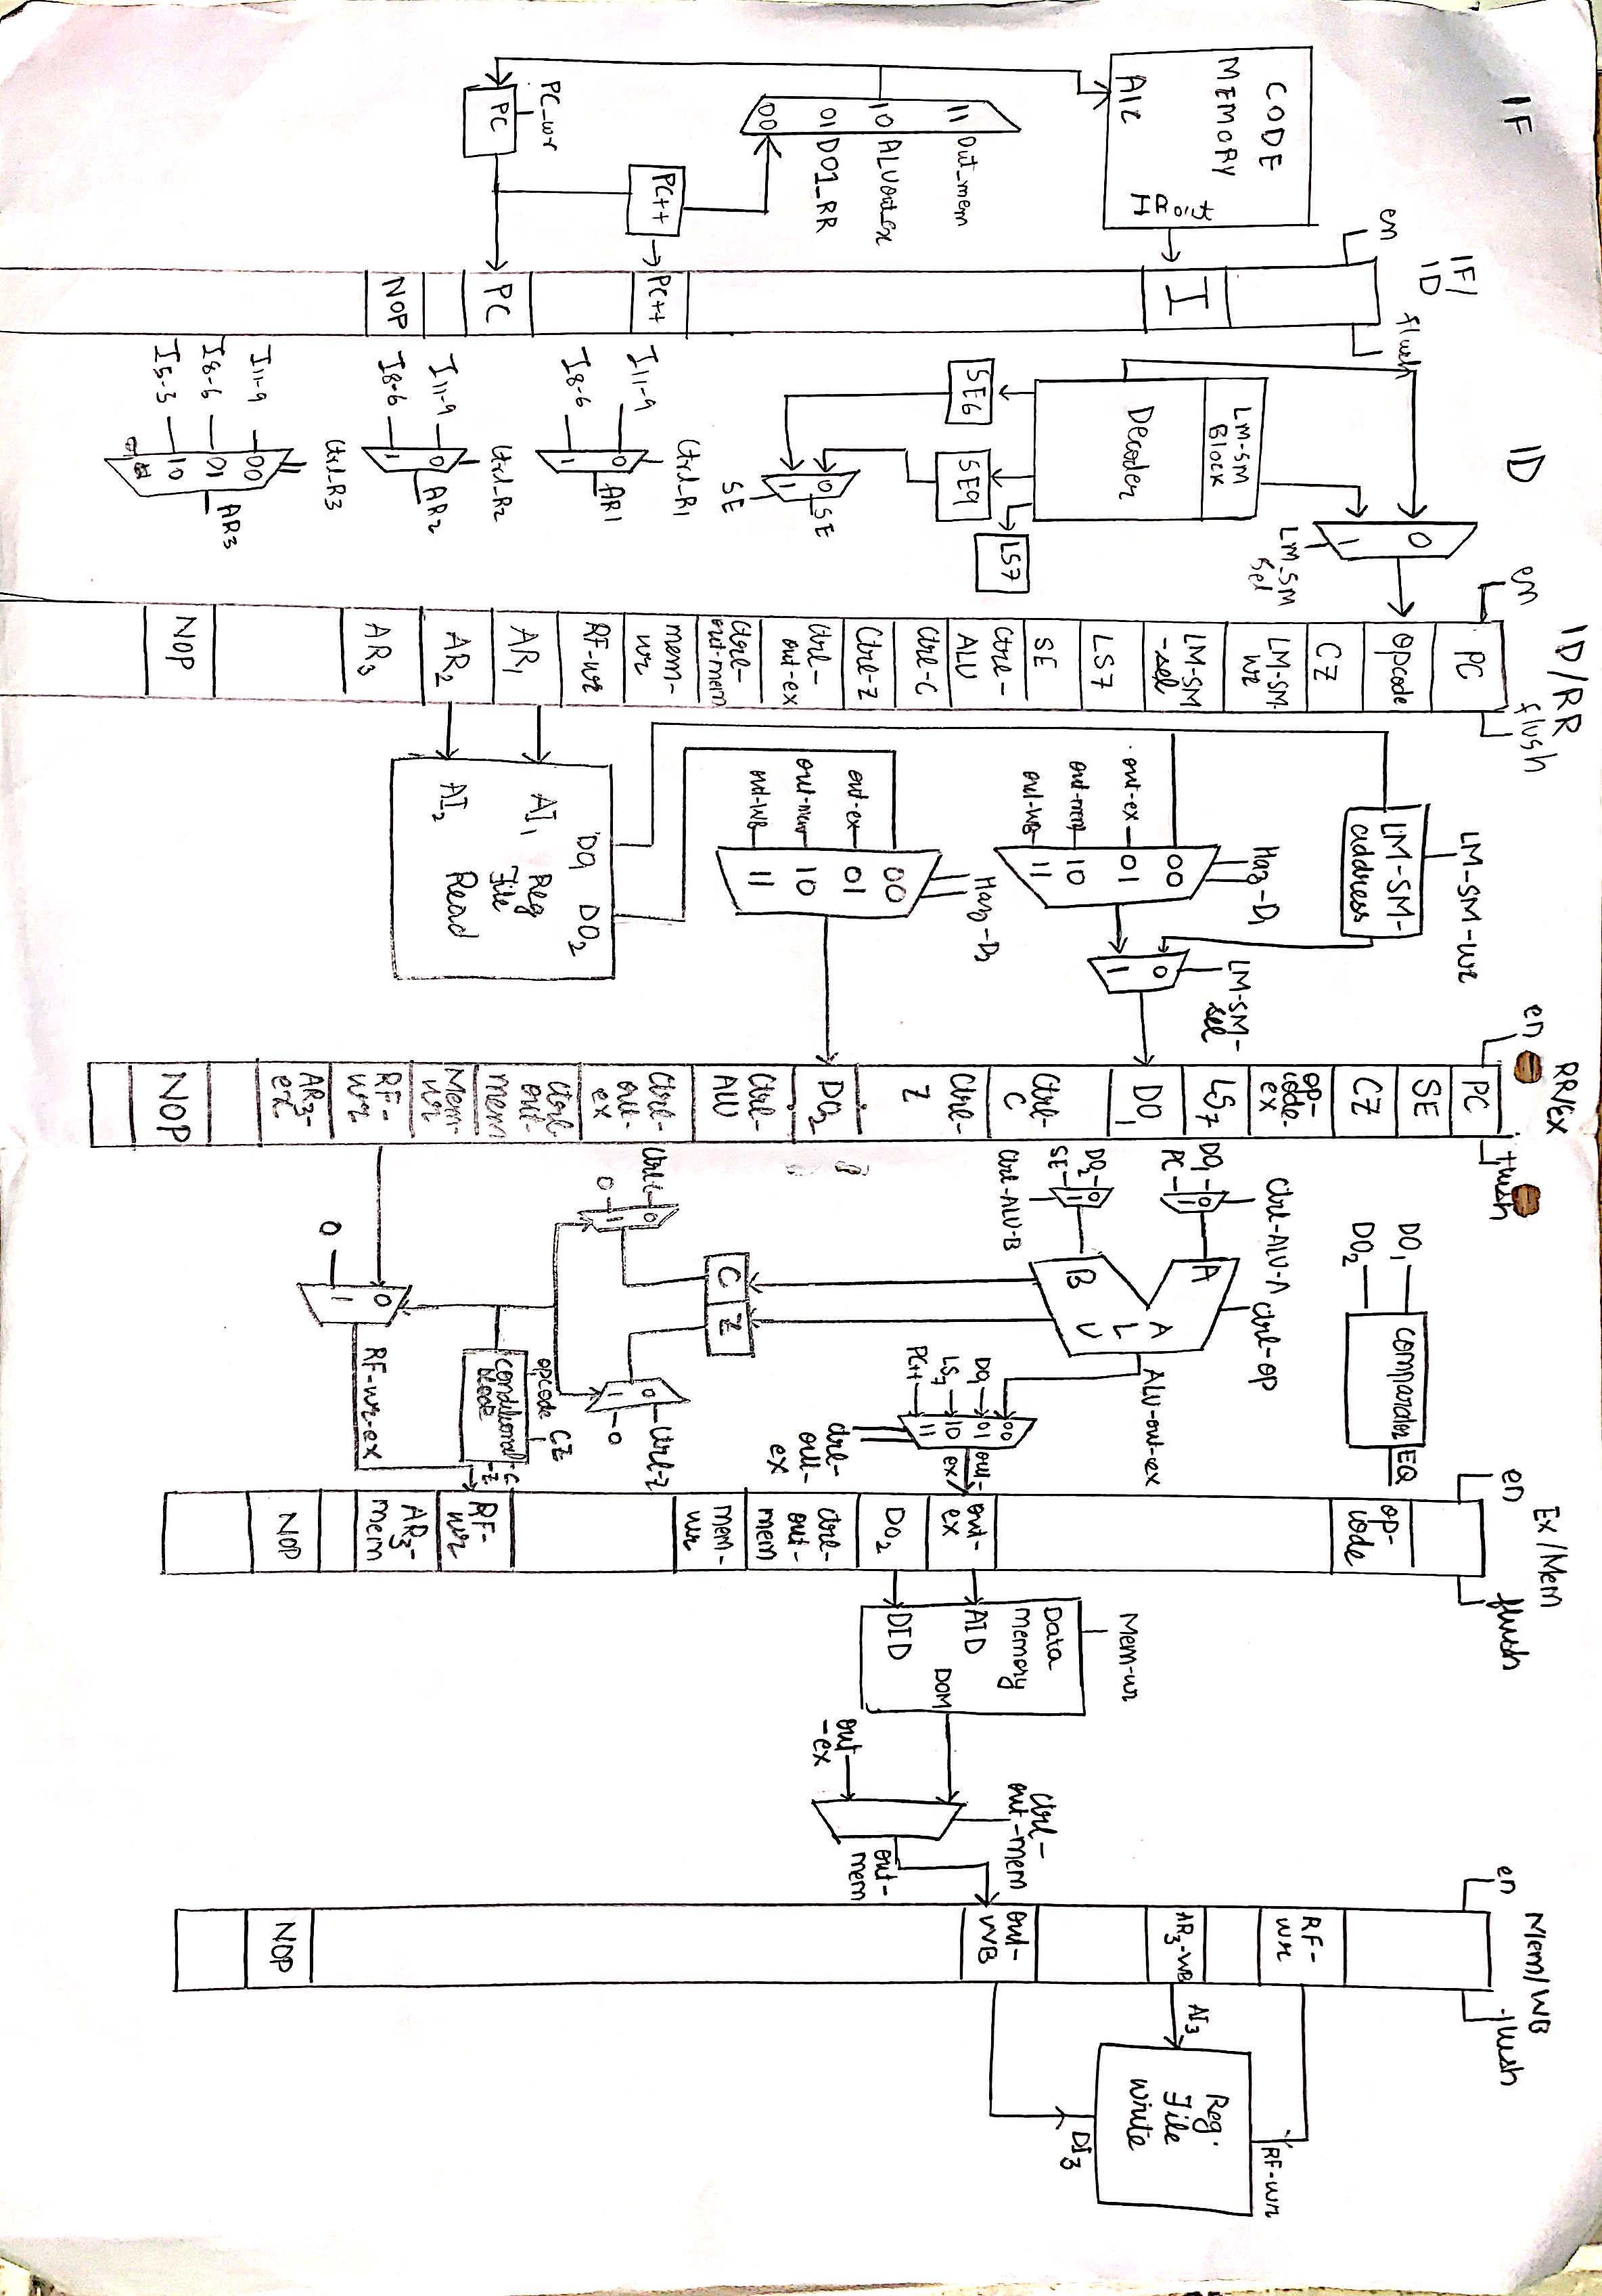

Instruction Fetch

- PC(R7): Points to the address of the next instruction.

- Code Memory: Read-only Instruction Memory (ROM) from which the instruction is obtained.

- PC++: Increments the PC value by 1 for the next possible instruction

- MUX: Control signal Haz_PC provided by the Hazard unit. It selects the next instruction from PC++, BEQ Branch taken hazard and data hazards having R7 as the destination register.

Instruction Decoder

- Decoder: Provides control signals according to the current instruction

- SE control signal: Selects from SE6,SE9

- LS7: Functional unit required for LHI instruction. It left shifts the input by 7 places.

- Ctrl_R1,Ctrl_R2,Ctrl_R3 control signals: Selects the required addresses to be passed down to the register file for reading/writing.

- LM/SM unit: Detects LM/SM instruction and passes the required values down the pipeline. Passes control signal for storing memory address in RR stage, addresses for reading from/writing to registers,Immediate(SE) value to compute next addresses and corresponding values for writing to Memory(SM) or Register File(LM).

- LM/SM MUX: To steer input from Instruction decoder and LM/SM unit. Gets 1(i.e. takes values from LM/SM unit) when LM/SM instruction is detected and is normally 0.

- SE6/9: Sign extends the Imm value(6-bit/9-bit) to 16-bit value.

Register Read

- Register File Read: Takes the addresses AI1,AI2 from the AR1, AR2 pipeline registers and outputs DO1,DO2 respectively.

- Haz_D1,Haz_D2 (MUXes): Control signals come from the Hazard unit. It steers data coming from Register file and the outputs of Execute, Memory Access and Write Back stages by detecting data hazards.

- LM/SM Register: Stores memory address for LM/SM instruction.

- LM/SM MUX: to steer data from LM/SM register and pipeline.

Execution

- ALU: Performs ADD/NAND operation depending on the control signal Ctrl_OP and outputs ALUout.

- Ctrl_ALU_A,Ctrl_ALU_B(MUXes): Control signals coming from RR/Ex register to steer the inputs for ALU.

- Comparator: Compares the inputs DO1,DO2 and outputs ‘0’ (if not equal) and ‘1’ (if equal) to the EQ flag to be used by hazard unit for BEQ branch taken hazard.

- Conditional unit (includes MUX): Checks for ADC/ADZ/NDC/NDZ instruction and disables writing to flags and registers when condition is not met.

- Ctrl_Out_ex (MUX): Steers between the inputs and chooses the one to be written to Register File.

- C : Carry flag to determine the carry of ALU operation and the write signal comes from Ctrl_C or from the Conditional unit.

- Z : Zero flag to determine if the ALU output is 0 and the write signal comes from Ctrl_Z or from the Conditional unit.

Memory

- Data Memory: Readable and writable data memory. Address for read/write comes from Out_ex and the data to be written comes from DO2. Write signal Mem_wr, Out_ex and DO2 come from the pipeline register Ex/Mem.

- Ctrl_out_mem: Steers between the input coming from data memory and from Ex/Mem register to determine the data to be written to Register File.

Write Back

- Register File Write: Takes Address(AR3), data(Out_WB) and RF_wr signal coming from the pipeline register Mem/WB. Data written only when RF_wr gets 1.

Pipeline Register Components

Pipeline Register | Components | Length(bits)
IF/ID | PC | 16
IF/ID | Instruction | 16
IF/ID | PC++ | 16
IF/ID | NOP_ID | 1
ID/RR | PC | 16
ID/RR | LS7 | 16
ID/RR | SE | 16
ID/RR | PC++ | 16
ID/RR | Ctrl_ALU :  - Ctrl_ALU_A  - Ctrl_ALU_B  - Ctrl_ALU_Op | 3  1  1  1
ID/RR | Opcode_RR | 4
ID/RR | LM_SM_wr | 1
ID/RR | LM_SM_sel | 1
ID/RR | Ctrl_C | 1
ID/RR | Ctrl_Z | 1
ID/RR | Condition bits(CZ) | 2
ID/RR | Ctrl_out_ex | 2
ID/RR | Ctrl_out_Mem | 1
ID/RR | AR1 | 3
ID/RR | AR2 | 3
ID/RR | AR3 | 3
ID/RR | RF_wr | 1
ID/RR | Mem_wr | 1
 | NOP_RR | 1
RR/EX | PC | 16
RR/EX | LS7 | 16
RR/EX | SE | 16
RR/EX | PC++ | 16
RR/EX | Ctrl_ALU :  - Ctrl_ALU_A  - Ctrl_ALU_B  - Ctrl_ALU_Op | 3  1  1  1
RR/EX | Opcode_Ex | 4
RR/EX | Ctrl_C | 1
RR/EX | Ctrl_Z | 1
RR/EX | Condition bits(CZ) | 2
RR/EX | Ctrl_out_ex | 2
RR/EX | Ctrl_out_Mem | 1
RR/EX | DO1 | 16
RR/EX | DO2 | 16
RR/EX | AR3_ex | 3
RR/EX | RF_wr | 1
RR/EX | Mem_wr | 1
RR/EX | NOP_ex | 1
EX/MA | Opcode_MA | 4
EX/MA | Out_ex | 16
EX/MA | DO2 | 8
EX/MA | Ctrl_Out_Mem | 1
EX/MA | RF_wr | 1
EX/MA | Mem_wr | 1
EX/MA | AR3_Mem | 3
EX/MA | NOP_Mem | 1
MM/WB | RF_wr | 1
MM/WB | AR3_WB | 3
MM/WB | Out_WB | 16
MM/WB | NOP_WB | 1

HAZARD DETECTION AND MITIGATION
Code for Hazard mitigation

1)Haz_D1 <= "01" when [(NOPex=0)&(RF_wr_ex=1)&(AR1=AR3ex)]
else "10" when [(NOPmem=0)&(RF_wr_mem=1)&(AR1=AR3mem)]
else "11" when [(NOPrb=0)&(RF_wr_rb=1)&(AR1=AR3rb)]
else "00";

2)Haz_D2 <= "01" when [(NOPex=0)&(RF_wr_ex=1)&(AR2=AR3ex)]
else "10" when [(NOPmem=0)&(RF_wr_mem=1)&(AR2=AR3mem)]
else "11" when [(NOPrb=0)&(RF_wr_rb=1)&(AR2=AR3rb)]
else "00";

3)Haz_PC <= "11" when [(Opcode_mem=LW OR Opcode_mem=LM)&(AR3mem=R7)&(RF_wr_mem=1)]
else "10" when [(NOPex=0)&(RF_wr_ex=1)&(AR3mem=R7) OR (Opcode_ex=BEQ & EQ=1)]
else "01" when [Opcode_rr=JLR]
else "00";

4)ID_RR_flush <= '1' when [(Opcode_mem=LW OR Opcode_mem=LM)&(AR3mem=R7)&(RF_wr_mem=1)]
or [(NOPex=0)&(RF_wr_ex=1)&(AR3mem=R7)]
or [Opcode_rr=JLR]
or [(Opcode_ex=BEQ)&(EQ=1)]
or [(Opcode_decode=JAL or Opcode_decode=JLR)&(AR3decode=R7)]
else '0';

5)RR_ex_flush <= '1' when [(Opcode_mem=LW OR Opcode_mem=LM)&(AR3mem=R7)&(RF_wr_mem=1)]
or [(Opcode_ex=BEQ)&(EQ=1)]
or [(NOPex=0)&(RF_wr_ex=1)&(AR3mem=R7)]
or [(Opcode_ex=LW OR Opcode_ex=LM)&(AR1=AR3_ex or AR2=AR3_ex)]
or [Opcode_ex=JAL]
else '0';

6)Ex_Mem_flush <= '1' when [(Opcode_mem=LW OR Opcode_mem=LM)&(AR3mem=R7)&(RF_wr_mem=1)]
or [(Opcode_ex!=LW OR Opcode_ex!=LM)&(NOPex=0)&(RF_wr_ex=1)&(AR3mem=R7)]
else '0';

7)Mem_WB_flush <= '1' when [(Opcode_mem=LW OR Opcode_mem=LM)&(AR3mem=R7)&(RF_wr_mem=1)]
else '0';

8)IF_ID_en <= '0' when [(Opcode_ex=LW OR Opcode_ex=LM)&(AR1=AR3_ex or AR2=AR3_ex)]
else '1';

9)ID_RR_en <= '0' when [(Opcode_ex=LW OR Opcode_ex=LM)&(AR1=AR3_ex or AR2=AR3_ex)]
else '1';

Data Hazards
Data is forwarded through 3 multiplexers : 1 at IF stage and 2 at RR stage. The MUXs at RR stage checks if any of the operand at RR stage depends on output of any instruction in further stages.
The MUX at IF stage mitigates hazards having R7 (i.e. PC) as destination by forwarding the data from corresponding stage. It also mitigates the BEQ Branch taken hazard.
Data Forwarding Priority: R7 > [Ex-MM] > [MM-WB] > [WB]
LW Hazard
When LW is followed by a dependent instruction, we stall for one cycle when LW is in the execution stage, and the RRex pipeline register is flushed. At the end of the Memory Access stage the appropriate data is forwarded to the dependent instruction.
Destination R7: At memory stage, data is forwarded to PC, and IDRR, RREx, ExMem and MemWB are flushed.
JAL/JLR
For JAL, at execution stage, the address is forwarded to PC and IDRR and RREx are flushed.
For JLR, at RR stage the address is forwarded to PC and IDRR is flushed.
Destination R7: At the decode stage IDRR is flushed
ADC/ADZ/NDC/NDZ
If the condition is met, data is forwarded, otherwise it is not. Whether to forward or not is controlled by RF_write_ex which is controlled by the conditional block.
Destination R7: As handled in data hazards
BEQ
We have adapted the static not taken approach. At execution stage, if we find that the branch to be taken, the address is forwarded and IDRR and RREx are flushed.
LM/SM
The decoder has an LM/SM block. In the register read stage there is a circuit for handling LM/SM instructions It has an LM/SM register controlled by an LM/SM write signal and a MUX controlled by an LM/SM select signal. The select signal selects the input to DO1 between the normal input and LM/SM register. The LM/SM register stores the value of Ra(which is the address of the first memory location).
For LM: RF_write comes from the LM/SM unit in the decoder and Mem_write is 0. The LM/SM unit sends the appropriate bit from the Imm into RF_write and sends values 0 through 7 in SE. The LM/SM unit sends 000 through 111 in AR3. Opcode and control signals of LW are sent forward. Hazard mitigation mechanism is same as that for LW.
For SM: Mem_write comes from Imm sent 1 by 1 by the LM/SM unit. Rf_write is 0. Stall IF/ID and Pc_write in the whole process except the last stage. Opcode and control signals of SW are sent forward. Hazard mitigation mechanism is same as that for SW.

